**Class 18/01/2022**

**Graph Theory**

**UG Semester-3**



**Tree**

**A tree is a connected graph without any cycle.**

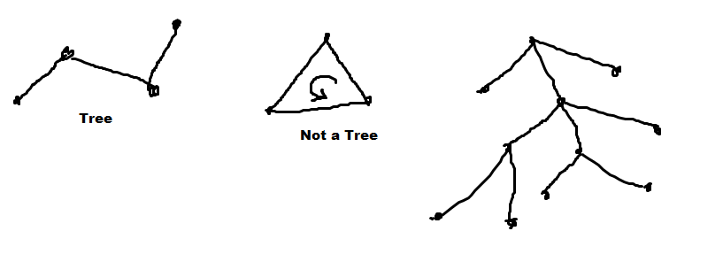

**Theoram-1 : There is one and only one path between every pair of vertices in a tree.**

Let there be two vertices x and y in a Tree T. As T is connected so there exist at least one path from x to y. Let there be two paths p1 and p2 exists between x and y. Then union of p1 and p2 will form a cycle. Hence it is a contradiction. So there exist one and only one path between any pair of vertices of T.

**Theoram-2 :If in a graph G there is one and only one path between every pair of vertices,G is a tree.**

In the graph G there exist a path between any pair of vertices of G. Hence it is a connected. As a circuit indicates that that there must exist more than one path between any pair of vertices. But in G there is one and only one path between any pair of vertices. Hence G doesn’t contain a circuit. Hence G is connected and circuit less. So G is a tree.

**Theoram-3: A tree with n vertices has n − 1 edges**.

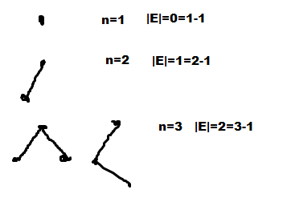

Let us consider it is true for n<ki.e a tree with k-1 vertices has (k-2) edges.

Let us consider a tree T with n=k vertices.

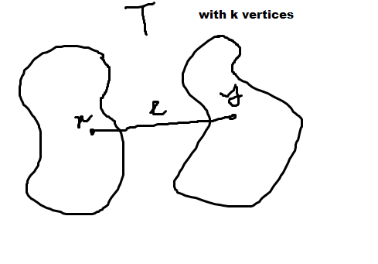

Let us consider two vertices x and y of T which are adjacent by an edge e. Now we delete the edge e from T then T will become disconnected as there exist one and only one path between any pair of vertices in T. We get two connected components say T1 and T2. As T1 and T2 are also circuit less hence T1 and T2 are trees.

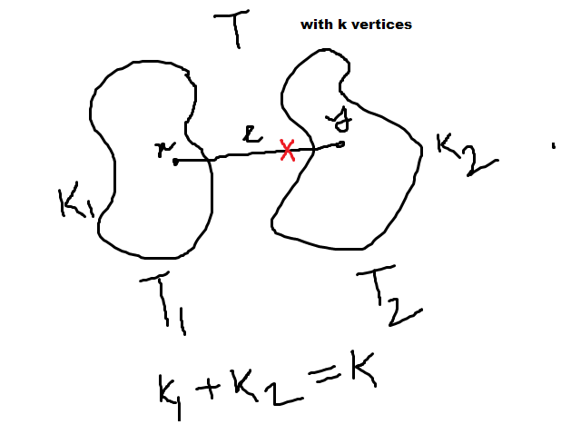

let T1 contains k1 vertices and T2 contains k2 vertices. As we have not deleted any vertex hence

k1+k2=k (1)

As T1 and T2 are tree hence k1, k2>0.

Hence k1 and k2<k.

From induction in T1 there are k1 vertices(<k) Hence T1 contains (k1-1) edges.

Similarly in T2 there are k2 vertices(<k) Hence T2 contains (k2-1) edges.

So T1 and T2 combined edges

=(k1-1)+(k2-1)=(k1+k2-2)=(k-2) edges

Now if we re-insert edge e between x and y then number of edge in T becomes

=(k-2)+1=(k-1) (Proved)

Theoram-4 : Any connected graphG with n vertices and n-1 edges is a tree.

Circuit k vertices edges k

Remaining edge (n-1-k)

k=2 remaining edge=n-3 remaining vertex=n-2

k=3 remaining edge=n-4 remaining vertex=n-3

……

k=n-2 remaining edge=(n-1)-(n-2)=1 remain vertex=2 To become connected we need at least two edges.

k=n-1 remaining edge=0. Hence the remain vertex which is not considered in the circuit was disconnected, which is a contradiction. Hence such a circuit is not possible.

If k=n then remaining edge=-1 which is again a contradiction. So such circuit is not possible.

Hence this graph G is circuit less and connected. Hence a tree.

**Minimally connected**: **A** graph G is minimally connected if deleting an edge disconnects the graph.

**Theoram-5: A graph is a tree if and only if it is minimally connected.**

Let us consider a graph G which is minimally connected. So removal of any edge from G disconnects the G. Let us assume that it has circuits. Let such a circuit be C in between two vertices x and y. So there exists two paths between x and y. Let these paths be p1 and p2. Now let us remove an edge from path p1. X and y will still remain connected as there exists another path p2. So removing this edge does not disconnect the graph G. Hence our assumption that G is minimally connected is contradictory.Hence G is circuit less. Hence G is a tree.

Let us consider a tree T. We know that there is one and only one path between any pair of vertices in a tree. Let us consider such a path be p1 between two vertices x and y. Now let us delete and edge e from p1. There will be no path between x and y and T will be disconnected. T become disconnected as a result of the removal of a single edge. So T is minimally connected.

**Theorem-6: A graph G with n vertices, n − 1 edges, and no circuits is connected**.

Let us consider a circuit less graph G with n vertices and n-1 edges which is disconnected.

G consists of two or more circuit less components. Without losing generality let the two components are g1 and g2. If we insert an edge between v1 vertex of g1 and v2 vertex of g2 then GUe graph is connected.

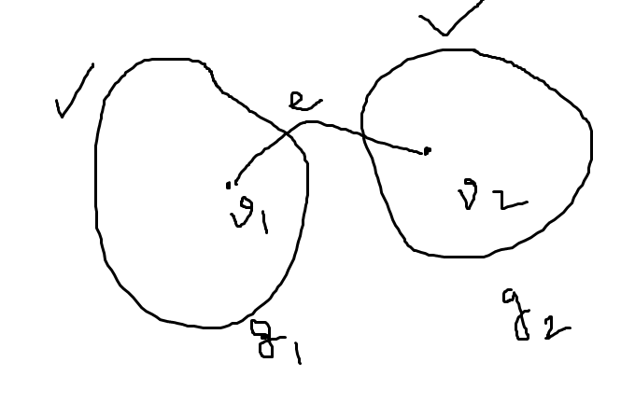

Since there was no path between v1 and v2 so adding edge e between v1 and v2 will no create any circuit. Hence GUe is also circuit less and connected with n vertices and n edges. But it is not possible. Hence G is not disconnected. (Proved)

#matrix evaluation

i=0

while [ $i-lt3 ]

do

j=0

while [ $j-lt3 ]

do

echo enter value

readval

index=`expr3 \* $i + $j `

arr[$index]=$val

j=`expr$j + 1`

done

i=`expr$i + 1`

done

echo matrix

i=0

while [ $i-lt3 ]

do

j=0

while [ $j-lt3 ]

do

index=`expr3 \* $i + $j `

echo-n" ${arr[$index]} "

j=`expr$j + 1`

done

echo

i=`expr$i + 1`

done

** bash main.sh**

**enter value**

**2**

**enter value**

**3**

**enter value**

**4**

**enter value**

**5**

**enter value**

**6**

**enter value**

**7**

**enter value**

**87**

**enter value**

**9**

**enter value**

**10**

**matrix**

**2 3 4**

**5 6 7**

**87 9 10**

****